To Access and Send Exhibitor Invitations

- From your company’s Dashboard, click on the Booth Promotion tab or on Invite Exhibitor Guests in Registration Tools.

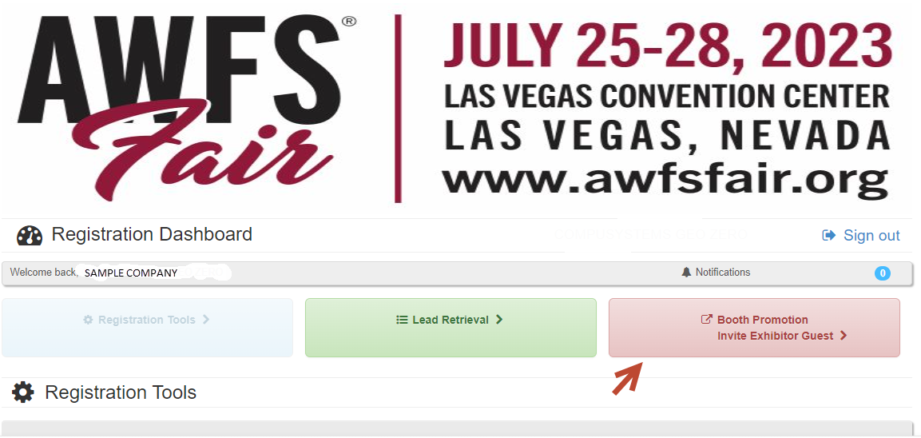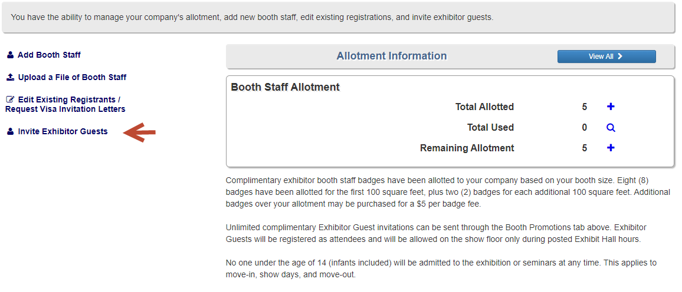

*If you click on the Booth Promotion tab, you will see the page below where you can then click on Invite Exhibitor Guests or Get Registration Widgets.
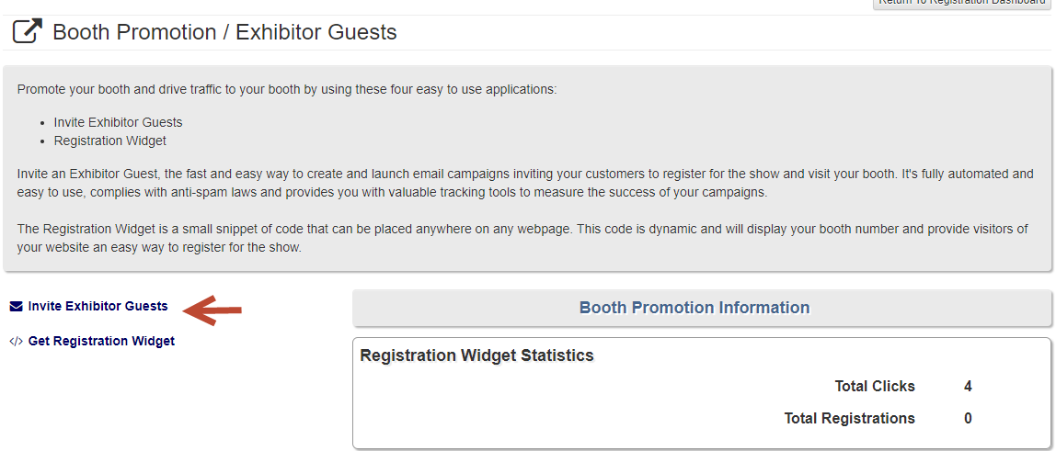

- You can either give your customer the code listed in Step 1 or in Step 2 you can send them an email that has a link for them to use to register via the attendee site using your company’s unique code.

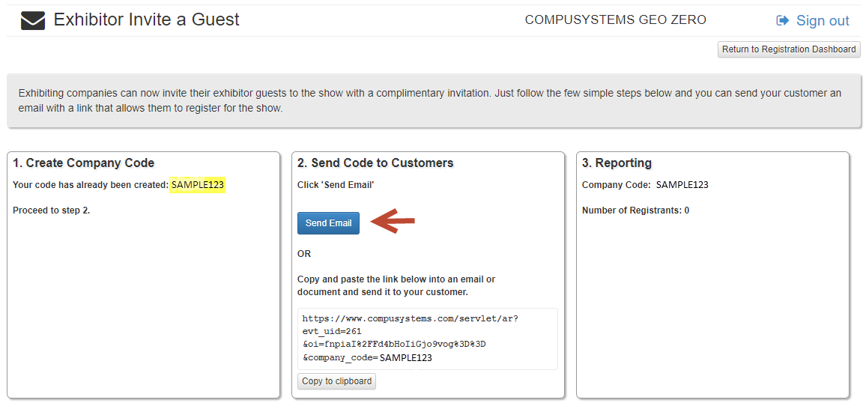

- When an attendee clicks on the registration link in your email, they will be taken directly to the attendee registration site where your unique code will pre-populate. If you didn’t send an email and gave your customer the code, they can enter it in the field shown below on the Attendee site.

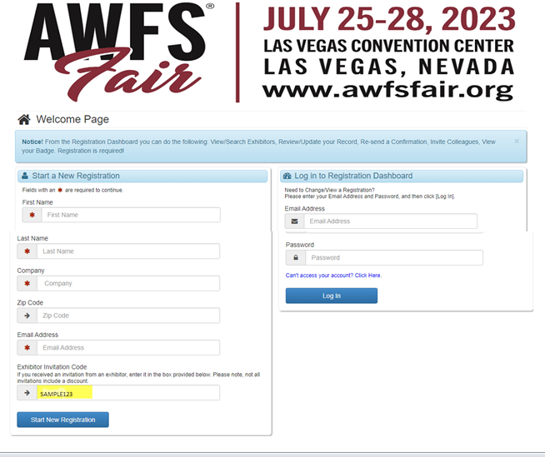

- From your company’s Dashboard, you can track who has registered using your code.

